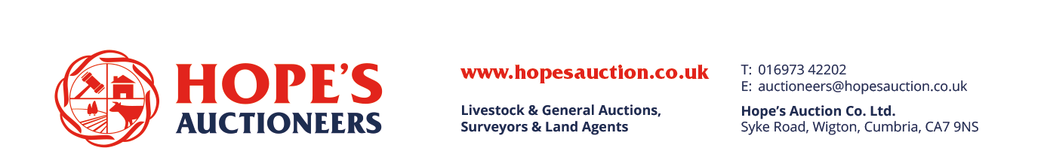
THURSDAY 11TH SEPTEMBER 2025
SALE OF PRIME CATTLE
PRIME CATTLE – 13
Topping today at 419.5pkg (£3007.82) a Limousin Heifer, weighing 717kg for J J Crichton, Loughrigg purchased by Tony Harrison Butchers, Cockermouth. Top gross of the day went to J S Dixon, Lesson Hall topping at £3155.79 (401.5p) for a Limousin weighing in at 786kg purchased by R J Harrison, King Street, Wigton.
Topping the Steer section went to a Limousin weighing 607kg reaching 414.5pkg (£2516.02). Top gross Steer went to £2846.07 (373.5p) from Newlands Farming, Hesket New Farm for a Limousin weighing 762kg.
More Prime Cattle required each week to fulfil buyers’ requirements, please contact David Fearon on 07500 173273 to advise of entries for our next sale.

Overall Averages – Bullocks 377.00pkg
Heifers 402.78pkg

Bullocks Sold Average pkg Max pkg.
551-650kg 1 414.50 414.50
651+kg 3 366.43 378.50

Heifers Sold Average pkg Max pkg.
591+kg 9 402.78 419.50

Top Bullock
Pence per kg Weight Breed Vendor
414.5 607 Limousin Messrs Cottam, Wardwarrow
378.5 697 Limousin D Hodgson, Croft Farm
373.5 762 Limousin Newlands Farm, Newlands House
346.5 693 Angus PT & SM Hewitson, High Stanger Farm

Top 5 Heifers
Pence per kg Weight Breed Vendor
419.5 717 Limousin J J Crichton, Loughrigg
417.5 688 Limousin Messrs J Dixon & Sons, Lesson Hall
413.5 666 Limousin Messrs Miller, Allerby Hall
409.5 613 British Blue Messrs Cottam, Wardwarrow
401.5 786 Limousin J S Dixon, Lesson Hall

PER KILO
STEERS
Limousin 414.5 Wardwarrow (Cottam) 378.5 Croft Farm (Hodgson) 373.5 Newlands House (Stobart)

Angus 346.5 High Stanger Farm (Hewitson)

HEIFERS
Limousin 419.5 394.5 Loughrigg (Crichton) 417.5 Lesson Hall (Dixon) 413.5 Allerby Hall (Miller) 401.5 Lesson Hall (J S Dixon) 391.5 389.5 Wardwarrow (Cottam) 389.5 Demesne Farm (Atkinson)

British Blue 409.5 Wardwarrow (Cottam)

PER HEAD
STEERS
Limousin £2846.07 Newlands House (Stobart) £2638.15 Croft Farm (Hodgson) £2516.02 Wardwarrow (Cottam)

Angus £2401.25 High Stanger Farm (Hewitson)

HEIFERS
Limousin £3155.79 Lesson Hall (J S Dixon) £3007.82 £2970.59 Loughrigg (Crichton) £2872.40 Lesson Hall (Dixon) £2777.14 Demesne Farm (Atkinson) £2753.91 Allerby Hall (Miller) £2738.19 £2552.58 Wardwarrow (Cottam)

British Blue £2510.24 Wardwarrow (Cottam)

