SPEED SHEAR COMPETITION
Friday 16th June saw Hopes Auction Company host their first Speed Shear, with an electric atmosphere from start to finish, the night was hailed a huge success by all who attended, with shearers travelling from across Northern England and Southern Scotland.
The eventually winner however came from over Seas, with Michael Jefferies from New Zealand clipping in a phenomenal 28.39 seconds in his heat and 31.12 seconds in the final to take the winners podium position, narrowly ahead of his travelling colleague Kapua Brown at 33.53 seconds. Both of these clippers are working with local shearing contractor Steven Watson based at Caldbeck, who had helped prepare the sheep for the evening, which were an outstanding run of Mule Hoggs kindly provided by the Peile family at Greystoke Castle.
The most hotly contested competition of the night was the highly anticipated all Cumbrian final, 15 local clippers took to the stand in the first round. Local clipping contractor and farmer Ashley Storey from Newbiggin, Kirklinton led the class with a very fast qualifying clip at 31.61 seconds and final clip at 34.96 seconds, narrowly beating Cockermouth based Ed Gate at 36.66 seconds. Ed had come from a big day clipping at Culgaith with his trailer mates from the day, Tom Blease and Jack Cartmel fighting it out for third and fourth in the local championship with a time of 39.14 seconds for Tom taking third and 39.39 seconds for Jack taking fourth.
The early evening saw the Novices and Intermediates take to the boards, in the Novice clippers, local shepherd Alex Bland from Clea Hall, set a strong opening time of 42.11 seconds narrowly beating his fellow Herdwick breeder Craig Fearon at 51.05 seconds and an extremely close third place for West Cumbria clipper, Adam Brown at 51.09 seconds.
The Intermediates were led by Dufton based Jack Wills from Fawcett Park with a very quick 37.62 seconds again just narrowly beating Cockermouth based Thomas Hird, who was travelling with a large supporting contingent, rewarding them with a very respectable 40.55 seconds. Third place travelled back to Penrith, with well-known shepherd Murray Craig from Thrimby Farms at 43.32 seconds.
The night was supported by Sponsors Burnetts Solicitors, Jack Cartmel Clipping Services and Dan Taylforth Sheep Scanning, as well as equipment provided by Highway Shearing at Skelton.
Following the outstanding success of the evening, planning for next year’s event is already underway and we look forward to welcoming people back to the 2024 Hopes Auction Speed Shear.
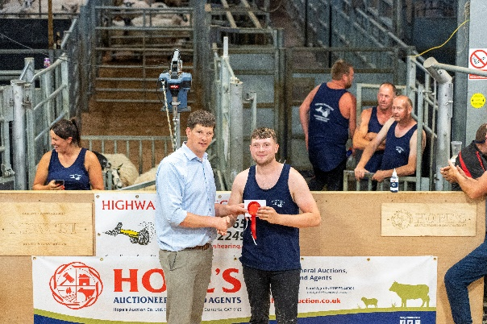
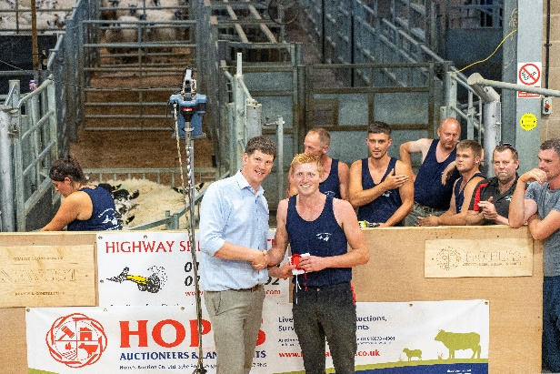

Winner of the Intermediate Class – Jack Wills from Fawcett Park (left) with Craig Brough (right) from Hopes Auction Co Ltd
Winner of the Novice Class – Alex Bland from Clea Hall (left) with Craig Brough (right) from Hopes Auction Co Ltd

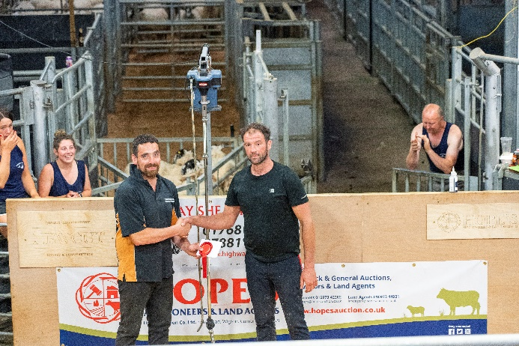
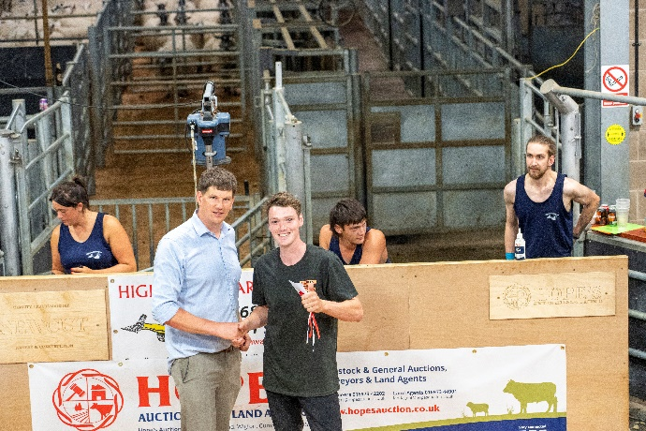

Winner of the Cumbrian Class – Ashley Storey (right) from Newbiggin, clipping in a time of 31.61 seconds and a final clip time of 34.96 seconds, with Sponsor Jack Cartmel Clipping Services (left)

Winner of the Open Class – Michael Jefferies from New Zealand (left), clipping in a time of 28.39 seconds in his heat and 31.12 seconds in the final, with Craig Brough (right) from Hopes Auction Co Ltd

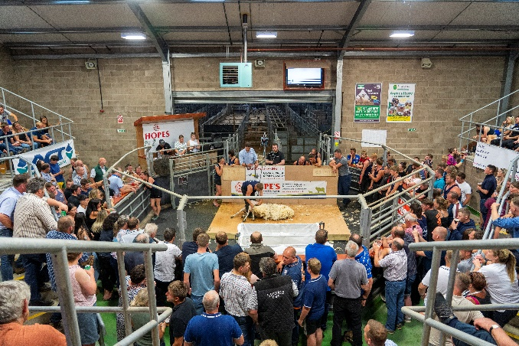
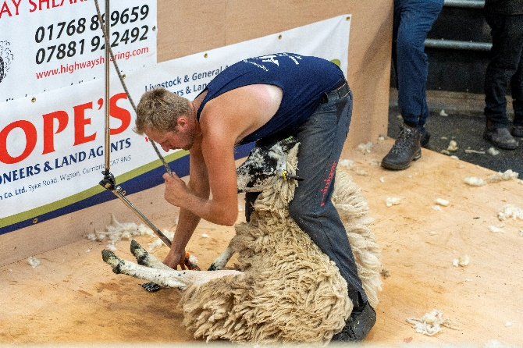
Declan Gill – Novice Class, clipping to a full ringside of spectators at the first Hopes Auction Speed Shear Competition
Robbie Graham – clipping in the
Cumbrian Class

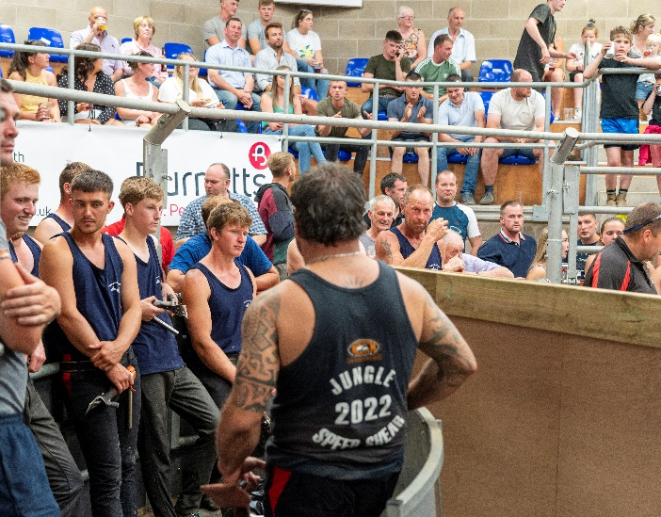

Shearers waiting for the Hopes Auction Speed Shear 2023 competition to commence.

