Ref: F37
Auctioneers • Surveyors • Valuers • Land Agents
Tel: (016973) 44901 ~ Email: landagent@hopesauction.co.uk
www.hopesauction.co.uk

FOR TENDER

APPROXIMATELY 313 ACRES
OF
GRASSLAND
AND
STUBBLES

SITUATED AT
DRYHOLME FARM, SILLOTH, CUMBRIA
AND
RED FLATT, SILLOTH, CUMBRIA

LOT 1 – Te grassland is let from tender date (30th March, 2022) until 28th October, 2022. A maximum of two cuts of silage may be taken with the purchaser to apply all fertiliser. The vendor reserves the right to apply digestate liquid with consultation with the taker at a suitable time. Nutritional advice of the digestate will be provided. Grazing with sheep only will be permitted until termination.

Lot 2, 3 and 4 – Arable Ground – These parcels are available on a stubble to stubble arrangement. The fields will be vacated upon removal of 2022 cropping and in any event prior to 15th October, 2022. All fields must be left uncultivated. No fertiliser or digestate will be applied.

WRITTEN OFFERS USING THE ENCLOSED FORM ARE INVITED FOR THE WHOLE OR IN LOTS
BY 12 NOON WEDNESDAY 30TH MARCH, 2022
Preliminary Particulars

SCHEDULE OF FIELDS
Field Number Hectares Acres

Lot 1 ALL GRASSLAND – SHADED BLUE
5224 3.93 9.71
5811 2.51 6.20
6708 2.13 5.26
7715 3.72 9.19
9463 3.98 9.83
1315 4.28 10.58
2592 7.10 17.55
1477 5.30 13.10
9680 3.48 8.59
0165 3.02 7.46
0554 2.49 6.15
2741 4.20 10.38
2148 5.25 12.97
4068 2.95 7.29

TOTAL 54.28 134.26

Lot 2 ALL ARABLE- SHADED RED

8840 5.21 12.87
0740 4.66 11.52
8620 3.09 7.65
9812 3.53 8.72

TOTAL 16.55 40.72
Lot 3 ALL ARABLE – SHADED ORANGE
2121 3.85 9.51
2909 2.02 4.99
1785 11.27 27.85
3576 10.59 26.17

TOTAL 27.73 68.52

Lot 4 ALL ARABLE – SHADED GREEN
0423 7.24 17.89
4062 5.40 13.34
0964 5.28 13.05
9952 2.53 6.25
9436 2.92 7.22
9523 2.72 6.72
1426 2.31 5.71

TOTAL 28.40 70.18

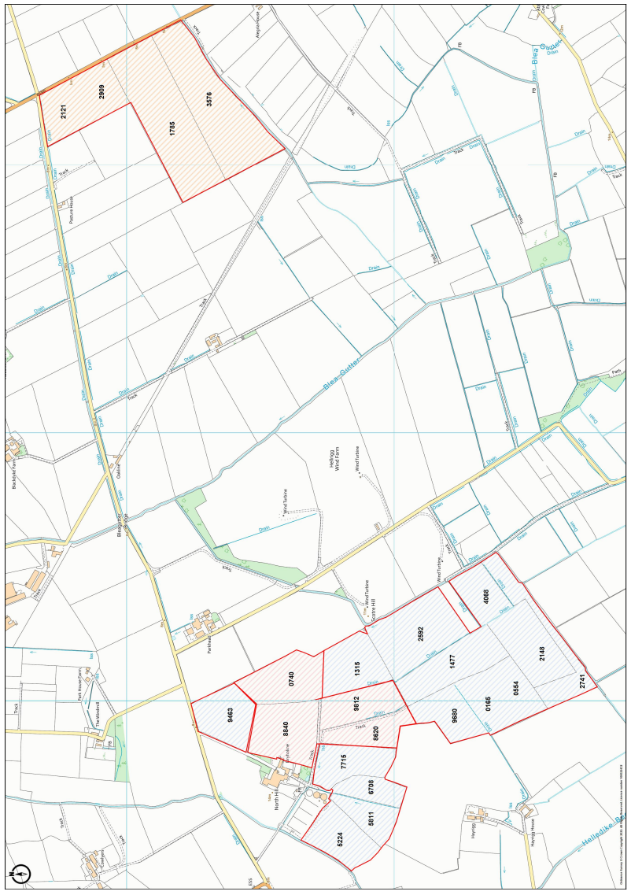

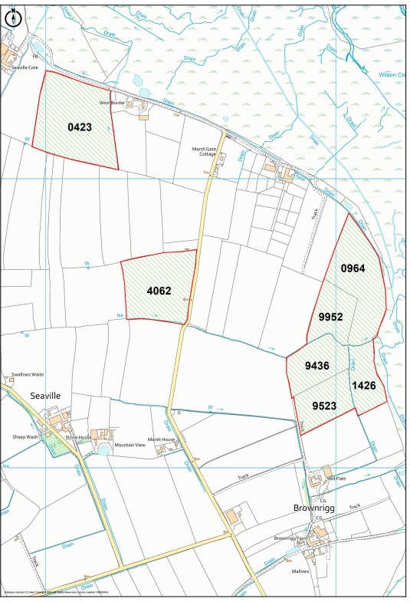

IMPORTANT NOTICE

These particulars have been prepared in all good faith without responsibility on the part of the agents or their clients to give a general guide only as to the property. Nothing contained herein must be relied upon as a statement or representation of fact. These particulars do not form any part of an offer or contract and neither the agent nor their employees have any authority to make or give any representations or warranties whatever in relation to this property. We have not tested any services, appliances or installations nor carried out a survey. Areas, measurements or distances are given as a guide only and are not precise. Only specific items referred to are included. Intending tenants must satisfy themselves by inspection or otherwise as to the correctness of these particulars and no responsibility can be accepted for any loss or expense incurred in viewing. If any points are particularly relevant to your interest please ask for further information.

Particulars Prepared March 2022

