Ref: F37
Auctioneers • Surveyors • Valuers • Land Agents
Tel: (016973) 44901 ~ Email: landagent@hopesauction.co.uk
www.hopesauction.co.uk

FOR TENDER

APPROXIMATELY 30.64 ACRES
OF
GRASSLAND

SITUATED AT
LOW HOUSE FARM, BRACKENTHWAITE,
WIGTON, CUMBRIA, CA7 8AP

To Let from 1st April, 2022 to 31st December, 2022
For sheep grazing and mowing only
Can be mown for up to two cuts. Slurry must be applied after cutting if mown.
Land is let unfertilised. Mains water to all fields.

WRITTEN OFFERS USING THE ENCLOSED FORM ARE INVITED FOR THE WHOLE OR IN LOTS
BY 12 NOON WEDNESDAY 30TH MARCH, 2022
Preliminary Particulars

SCHEDULE OF FIELDS

Field Number Hectares Acres

NY2945-3996 1.11 2.74
NY2945-4564 1.61 3.98
NY2945-4773 2.00 4.94
NY2945-5082 2.23 5.51
NY2945-5389 0.99 2.45
NY2945-6163 1.87 4.62
NY2945-6001 0.53 1.31
NY2945-4997 2.06 5.09

TOTAL 12.40 30.64

IMPORTANT NOTICE

These particulars have been prepared in all good faith without responsibility on the part of the agents or their clients to give a general guide only as to the property. Nothing contained herein must be relied upon as a statement or representation of fact. These particulars do not form any part of an offer or contract and neither the agent nor their employees have any authority to make or give any representations or warranties whatever in relation to this property. We have not tested any services, appliances or installations nor carried out a survey. Areas, measurements or distances are given as a guide only and are not precise. Only specific items referred to are included. Intending tenants must satisfy themselves by inspection or otherwise as to the correctness of these particulars and no responsibility can be accepted for any loss or expense incurred in viewing. If any points are particularly relevant to your interest please ask for further information.

Particulars Prepared March 2022

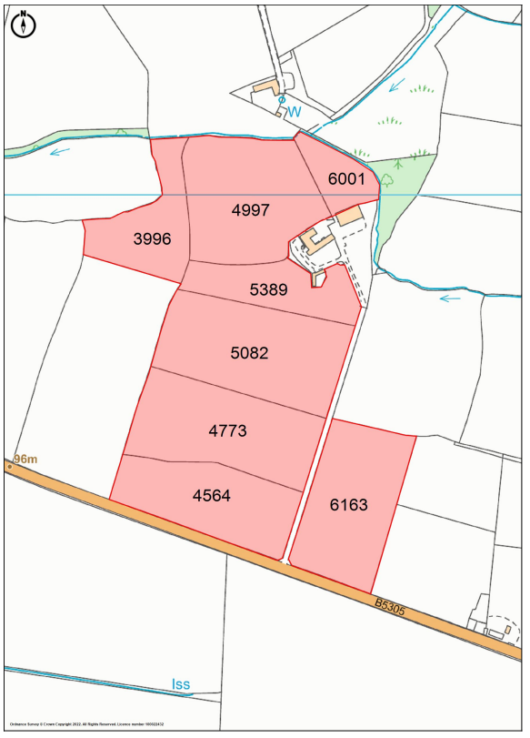

TENDER FORM

LAND AT LOW HOUSE FARM, BRACKENTHWAITE,
WIGTON , CUMBRIA, CA7 8AP

To Let from 1st April, 2022 to 31st December, 2022

For sheep grazing and mowing only

Can be mown for up to two cuts. Slurry must be applied after cutting if mown.

Land is let unfertilised.

Mains water to all fields.

12.40 Ha 30.64 Ac £ ________________

NAME: _____________________________________________________________

ADDRESS: _____________________________________________________________

_____________________________________________________________

CONTACT NO _____________________________________________________________

ALL TENDERS TO BE RECEIVED IN A SEALED ENVELOPE BY
12 NOON ON WEDNESDAY 30TH MARCH, 2022

