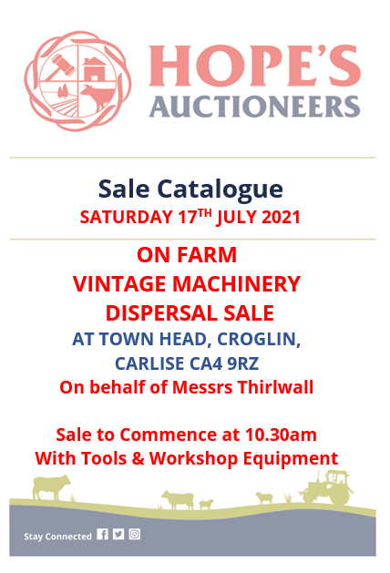

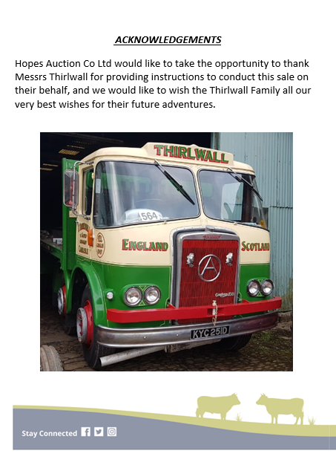

SCHEDULE OF MACHINERY TO BE SOLD

An outstanding collection of Vintage David Brown Tractors
- 2 x David Brown 900 Diesel Tractors
- David Brown 950 Tractor - To Restore
- Atkinson Mark 1 150 Gardener Flat Bed Wagon - 8 Wheeler
- David Brown 1690 - 6 Cylinder 103hp Tractor
- David Brown 990 Diesel Tractor
- David Brown 880 Diesel Tractor – 3 Cyclinder
- 2 x David Brown 1212 Hydra Shifts Tractors
- David Brown VAK1 1942 Tractor
- David Brown VAK1A 1946 Tractor
- VAG1C Cropmaster 1948
- VAG1C Cropmaster 1948 Perkins Conversion – ONLY ONE IN THE COUNTRY
- David Brown 25C 1956
- 5 x David Brown Ploughs
- 4 x Ordinary 2 Furrow Ploughs
- Deep Digger
- 3 Furrow Plough
- 1 set Ransome Discs
- Fowler Stationary Engine
- Three Point Linkage Kidd Saw Bench
- Tow Compressor
- Converted Trailer Plough
- Trailer Plough
- 1 set Ferguson Discs
- Lister Stationary Engine Generator
- 2 x Stationary Engines
- Quantity of heavy steel fencing
- Tipping Trailer
- Car Transporter
- 2 x Electric Compressors
- 3 x Arc Welders
- Miscellaneous David Brown Parts
- Miscellaneous Tools
- Miscellaneous Drills & Grinders
- Various Work Shop Tools
- Cement Mixer
- Steam Cleaner
- Various Truck Tractor Wheels
- Lawn Mowers
- 2 x Generators

Approximately 200 lots in total together with Inputs by Arrangement

MACHINERY SALES TO INCLUDE
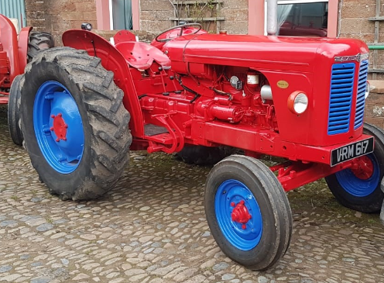

1958 - VRM 617
David Brown 900 Diesel Tractor
Fully Restored to a High Standard

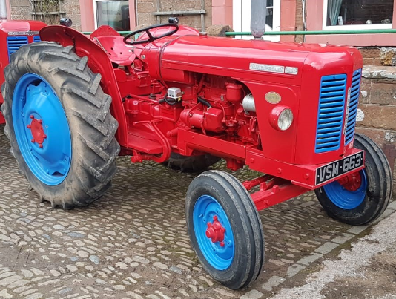

1957 – VSM 663
David Brown 900 Diesel
Ready to Show
Off set Steering

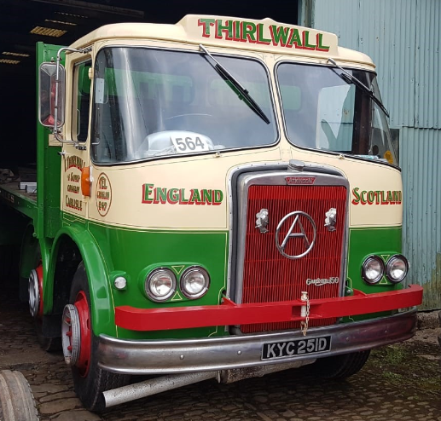

Atkinson Mark One 150 Gardener Flat Bed Wagon - 1966
8 Wheeler
Total Nut Bolt Restoration
Engine Fully Restored
Has not done 10,000 mile since winch
Fully Road Legal

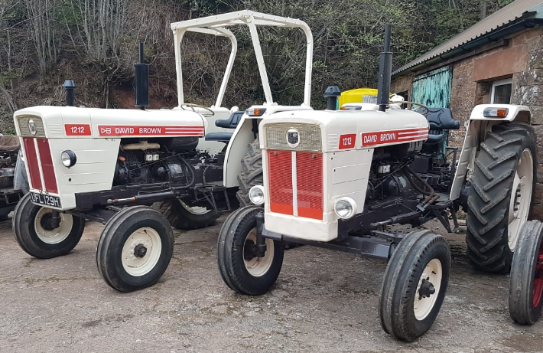

2 x David Brown 1212 Tractors
1971-1976
Hydra Shifts
Fully Restored High Standard
Owned nearly 10 years

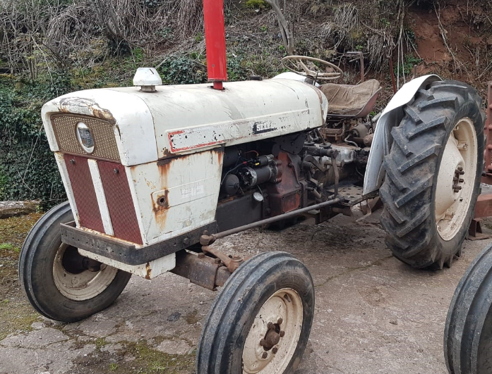
David Brown 880
1966
3 Cyclinder Diesel Tractor
Good working order, with good tyres

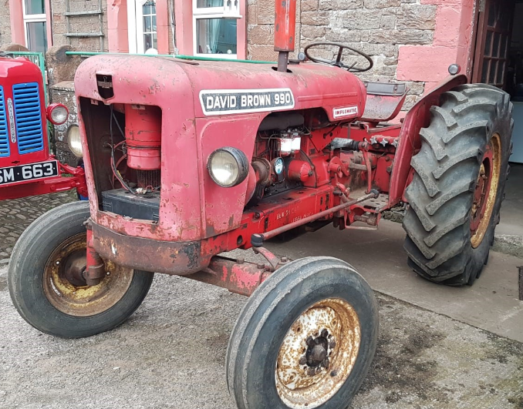

David Brown 990
1965
Diesel
Good Mechanically, fair condition
Good tyres

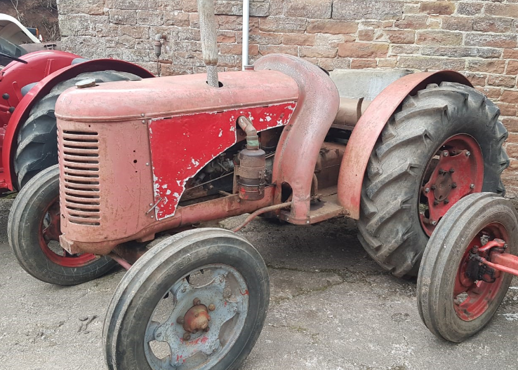
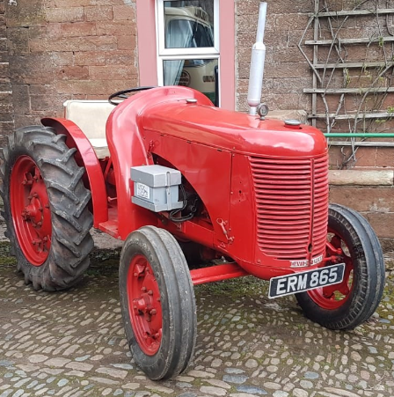

VAK 1A – 1946
Single gear box
Needs Restored
Does run

VAK 1 – ERM 865
1942
Very good order
Later restoration, converted to electric start
Rubber tyres, cast grill
Hydraulic pack

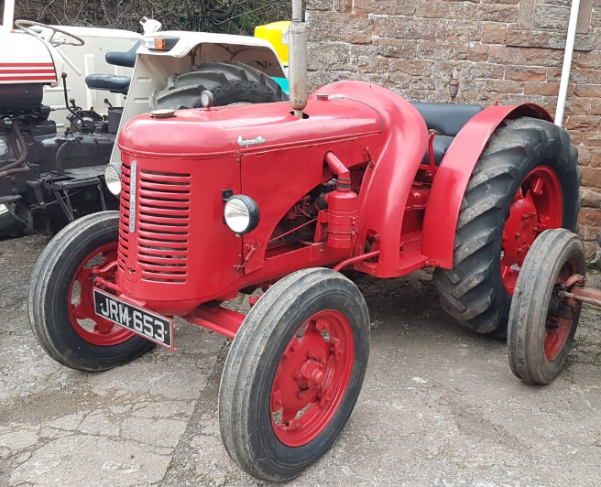

VAG 1C CROP MASTER – JRM 653
1948
Restored, good runner

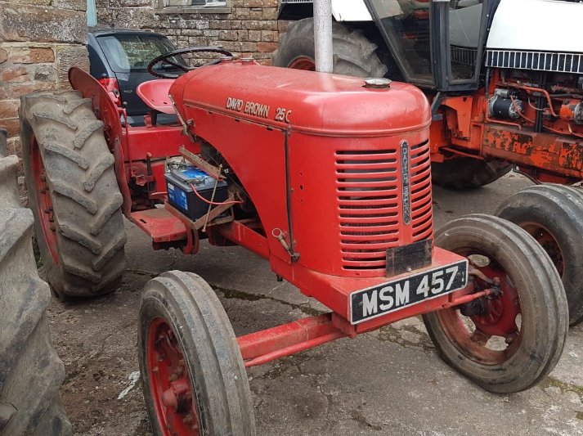

David Brown 25C – MSM 457
1956
Good Runner
Decent tyres
Old Restoration
Petrol/Parafin

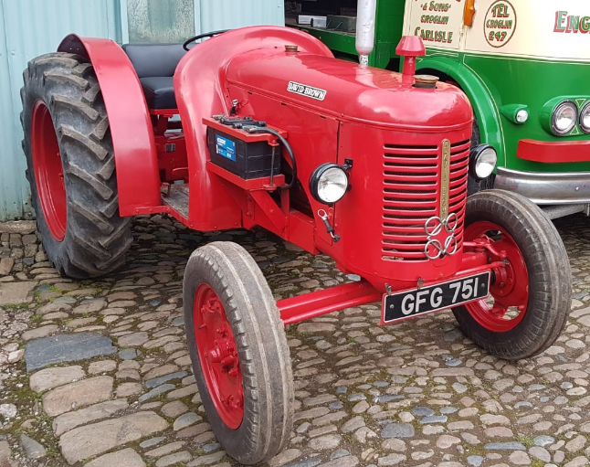

VAG 1C CROPMASTER – GFG 751
1948
Perkins conversation, very good restoration
ONLY 1 IN THE COUNTRY

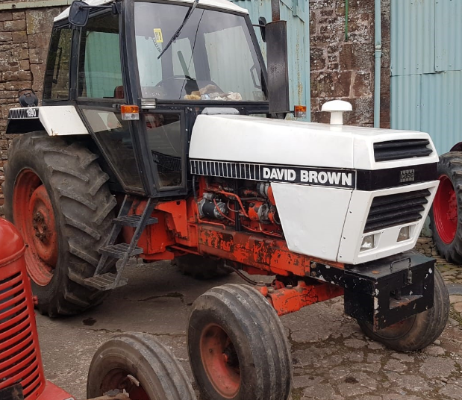

David Brown 1690
1980
103hp – 6 Cyclinder
Hydra Shift
Good Order
Everything works well

NOTES
- VIEWING ON THE FARM ON THURSDAY 15TH JULY AND FRIDAY 16TH JULY 2021 BETWEEN 10AM AND 4PM
- BUYERS PREMIUM 5%
- VAT CHARGED AT 20%
- CARD PAYMENTS AVAILABLE.
- CHEQUE AND CASH ACCEPTED.
- ANY PURCHASERS WHO HAVE NOT TRADED WITH HOPES AUCTION CO LTD, PLEASE PROVIDE REFERENCES PRIOR TO BIDDING.
- ALL BUYERS TO REGISTER FOR BUYER NUMBER BIDDING.
- CATERERS WILL BE IN ATTENDANCE

INPUTS ALSO BE INCLUDED IN THE SALE
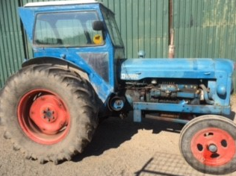
Fordson Major – JDO 65
1655
6 Cyclinder diesel engine
Good working order, lights work

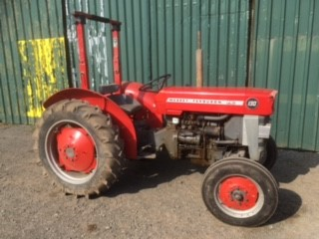
Massey Ferguson – 130
1966
PLG 188D
Built in France
Good working order

