Ref: M73 PRELIMINARY PARTICULARS

**HOPE’S**

**Auctioneers • Surveyors • Valuers • Land Agents**

Email: landagent@hopesauction.co.uk

www.hopesauction.co.uk

**Particulars of Sale of**

**PARK FOLD,**

**OULTON, WIGTON, CA7 ONG**

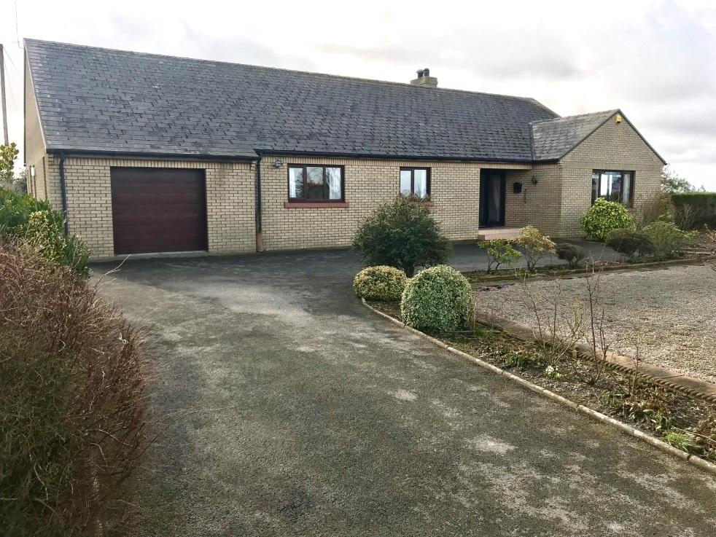

**An extremely desirable small holding with a**

**sizable three bedroomed bungalow, range of farm buildings and adjoining land extending to approximately 36.70 acres (14.85ha)**

**EPC: Band F**

**FOR SALE BY PUBLIC AUCTION IN 3 LOTS OR AS A WHOLE**

**on Tuesday 24th April, 2018 at 1.30pm within Hopes Auction Mart.**

**Sole Agents:**

Hopes Auction Company Limited

Syke Road

Wigton

Cumbria

CA7 9NS

Tel: 016973 44901

**Solicitors:**

Beaty & Co

1 Victoria Place

Wigton

Cumbria

CA7 9PJ

Tel: 016973 42121

**PARTICULARS OF SAL**

**Particulars of Sale**

**Introduction/Location**

Park Fold is a desirable small holding situated within the village of Oulton approximately two miles north west of Wigton as shown on the attached location plan.

**Viewing**

Strictly by appointment with the Sole Agents, Hopes Auction Co Ltd, Syke Road, Wigton,

Cumbria, CA7 9NS, Tel: 016973 44901, Email: landagent@hopesauction.co.uk.

**Method of Sale**

The property will be offered for sale by Public Auction in 3 separate lots or as a whole subject to reaching an undisclosed reserve price. For those unfamiliar with the auction process each individual lot will be offered for sale individually and reserved in favour of the highest bidder. The property will then be offered for sale as a whole and once again withdrawn in favour of the highest bidder. At this stage the auctioneer will withdraw from the auction room and take further instructions from the vendors prior to reoffering the property either in lots or as a whole. Please take note that any guide prices issued are not the reserve prices. The Vendors reserve the right to alter, divide, amalgamate or withdraw any part of the lots and to generally amend the order of sale. Any changes will be made clear at the public auction.

**Deposits and Contracts of Sale**

A 10% deposit of the purchase price will be payable on the fall of the auctioneers hammer and the contract of sale is to be signed. Cash deposits cannot be accepted due to Money Laundering Regulations. Payment is to be made by cheque or bankers draft. Copies of the sale contract will be available for inspection, by prior appointment only, at the offices of the Sole Agents during the week prior to the Public Auction.

**General Description**

The property is to be offered in three separate lots and as a whole. These can be described as follows:-

**Lot 1**

Lot 1 consists of the bungalow which provides spacious accommodation as follows:-

**Front Hallway**

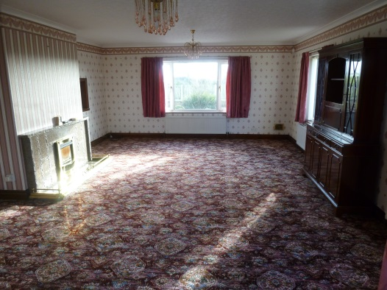**Sitting Room** 7.25m x 4.85m max with service hatch to kitchen.Sliding doors provide access through to

**Dining Room** 3.65m x 4.85m.

**Kitchen** 4.10m x 4.20m. A modern fitted kitchen with wall and floor units together with gas central heating boiler, stainless steel sink unit with sink drainer, integrated Indesit double oven and tiled flooring.

**Utility Room** 3.10m max x 3.35m max with stainless steel sink unit and single drainer. Tiled floor. Part tiled walls. Cupboard. Wall and floor units. Rear entrance porch of aluminium frame construction.

***Sitting Room***

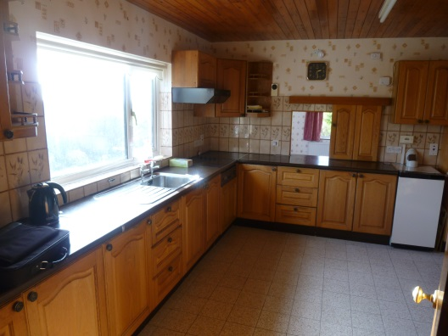**Rear Hallway** with broom cupboard.

**Bedroom 1** 4.25m x 2.46m max. A double room with built in cupboard.

**Bedroom 2** 4.25m x 4.25m. A large double room.

**Bathroom** 2.90m x 2.75m with three piece suite and separate electric corner shower. Part tiled walls.

**Bedroom 3** 4.10m x 4.25m. A double room.

**Integral Garage** 6.05m x 4.10m with electric insulated up and over door and separate doorway to outside elevation.

***Kitchen***

The property was constructed in the late 1970’s/early 1980’s. We are informed by the Vendor that it is of cavity wall construction under a fibre cement tiled roof.

**Floor Plan**

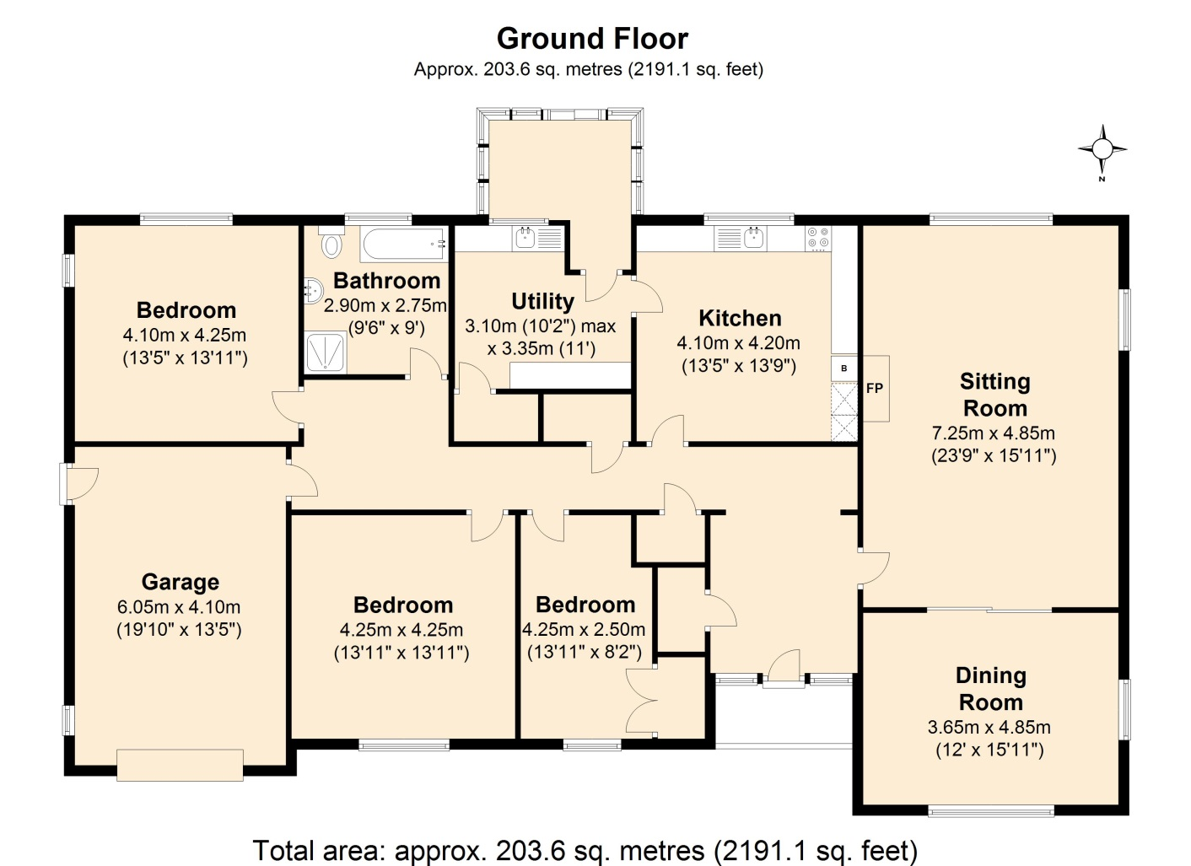

**Services**

The property benefits from a mains water supply, mains electricity supply and mains sewerage. It is heated by an LPG central heating system with above ground gas tank situated in the rear garden. The telephone is fitted subject to British Telecommunications Regulations.

**Council Tax**

We understand that Allerdale Borough Council has scheduled the property as lying within Band D. The amount payable for the 2017/2018 period was £1281.02.

**Outside**

To the front elevation of the property is a tarmac parking area with adjoining area covered with stone chippings. To the side elevation is a small lawned area together with greenhouse together with an adjoining patio area.

**Lot 2**

Lot 2 consists of the farm buildings which are situated to the east of Lot 1. The farm buildings have two accesses from the highway. The access to the west has a right of way over it benefitting the former farmhouse called Park House. The eastern access is to have a right of way granted over it to serve Lot 3 (marked A-B on the sale plan).

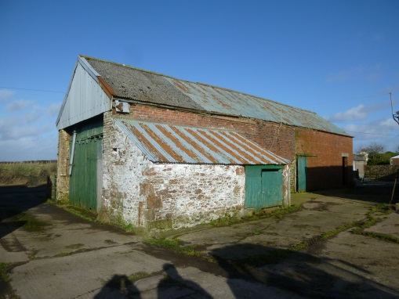

The farm buildings consist of a mixture of both traditional and semi-modern construction. They briefly consist of the following:-

**Small Storage Shed** of brick construction under a tiled roof.

**Traditional Barn** of predominantly brick and stone construction under a mixture of tile, slate, corrugated steel sheeting and asbestos cement roof sheeting. The building was formerly used for general purpose storage and requires substantial renovation.

***Traditional Barn***

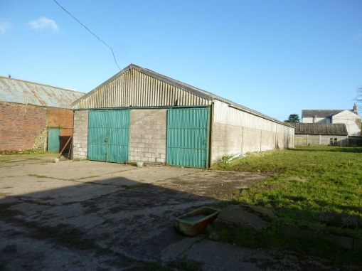**Stone Built Lean-to** to the above building used for general purpose storage. This building has a corrugated steel sheeted roof.

**Single Story Traditional Range** of brick, stone and concrete block construction under a slate roof consisting of three adjoining cattle loose boxes.

**Six Bay Steel Portal Framed Building** used for cattle loose housing with tubular steel feed barrier. Asbestos cement roof. Concrete block walls. Timber space board side cladding.

***Six Bay Steel Portal Framed Building***

**Lot 3**

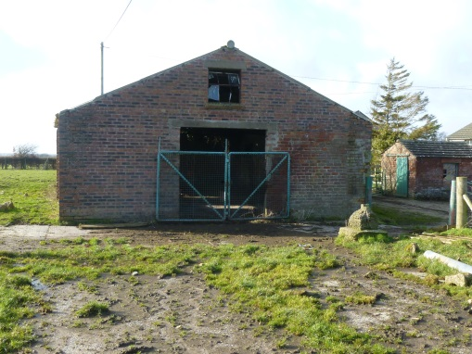Lot 3 is the agricultural land which currently forms part of the property. It is situated adjacent to Lots 1 and 2. The area of the land extends to approximately 36.70 acres (14.85ha) and has the benefit of roadside access into field 6749. Included within the land is a former 28 stall byre of brick and stone construction under an asbestos cement roof which is now used for the storage of farm machinery. All of the agricultural land is sown down to grass. Field 6749 and 7755 have mains water supplies. A spring fed supply also serves field 9239 and 6749. Field 5930 does not have a water supply.

***Brick built byre***

**General Remarks**

**Tenure**

The property is to be sold with the benefit of freehold vacant possession.

**Vacant Possession and Completion**

Vacant possession to all of the property will be given immediately on completion which is scheduled to occur on Friday 8th June, 2018.

**Water Supplies**

Currently one mains water supply serves Lot 1, Lot 2 and Lot 3. If the property is sold separately the Vendors will make arrangements for separate water supplies to be installed at their expense following the auction and prior to completion of sale.

**Electricity Supplies**

If the property is sold in three separate lots the electricity supply to Lots 2 and 3 will be disconnected and the purchaser will need to make their own arrangements for new supplies.

**Rights of Way**

As mentioned earlier in these particulars a Right of Way is to be granted over Lot 2 between the points marked A-B on the sale plan to benefit the purchaser of Lot 3. In addition an existing Right of Way exists over Lot 2 affecting the access situated adjacent to the property known as Park House. The maintenance liability for the area marked A-B is to be borne equally between the purchaser of Lot 2 and Lot 3. Details of the existing access to the western access point can be obtained from the Vendors solicitors, Beaty & Co (Maria Wright dealing) Tel: 016973 42121.

**Energy Performance Certificate (EPC)**

An extract from the EPC showing the current and potential Energy Efficiency Rating is shown below. Full copies of the EPC can be obtained from the Sole Agents (by prior appointment only).

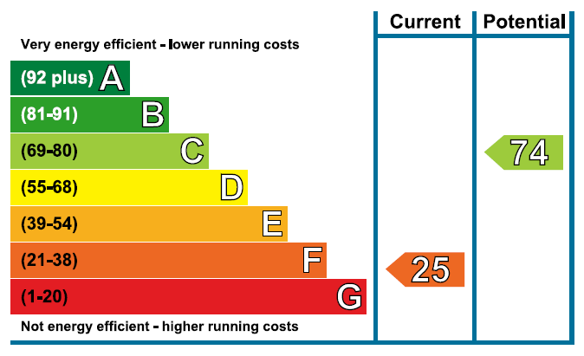

**Basic Payment Scheme**

All of the agricultural land will be used by the vendors to claim Basic Payments for the 2018 year. The vendors will retain the 2018 payments. The purchaser of Lot 3 will be bound to abide by the rules of Cross Compliance so that penalties are not imposed by the RPA. Entitlements for the 2019 scheme year will be included in the sale and transferred to the purchaser of Lot 3 in early 2019.

**Matters of Title**

The property is sold subject to all existing burdens (covenants, rights of way, wayleaves, easements, drainage easements, rights of maintenance, ancient monuments, scheduled monuments etc) whether public or private and whether constituted in the title deeds or not. The purchasers will be held to have satisfied themselves as to the nature of such burdens and are advised to contact the Vendors Solicitors on any matters arising.

**Mineral Rights and Sporting Rights**

We understand from the Vendors solicitors that the Mineral and Sporting Rights form part of the property’s title in so far as they are owned. Please contact the Vendors solicitors for further details.

**Ingoings**

There are to be no ingoing claims affecting any of the lots.

**Boundary Maintenance**

The maintenance liability for the property is shown in the usual manner with inward facing “T” marks denoting liability. Where no “T” marks exist the responsibilities are not known.

**Possible Planning Potential on Lot 2**

Lot 2 may hold potential for conversion of the buildings. However, no approach has been made to the local planning authority at Allerdale Borough Council. Potential purchasers will have to make their own enquiries direct to Allerdale Borough Council.

**Important Notice Effecting Lot 2 and Lot 3**

The property is sold subject to a Covenant stating that the buildings to the rear elevation of the property known as Park Fold can only be used for the purposes of agriculture. In our opinion this therefore effects the small storage shed on Lot 2 and the building on Lot 3.

**Purchaser Registration**

As part of the new Money Laundering Regulations relating to sale of property by public auction we as selling agents are obliged to carry out Customer Due Diligence checks on any potential purchaser prior to a transaction being completed.

We are therefore forced by law to ensure that potential purchasers are registered with ourselves at least 5 days prior to the auction. Please note that no one will be able to bid at the auction unless they are registered with ourselves at least 5 days prior to the auction. Please contact the Land Agency office for further information and also refer to the covering letter attached to these particulars for further details.

**SCHEDULE OF FIELDS**

**Field Number Hectares Acres**

**Lot 3**

**6749 6.07 15.00**

**5930 1.96 4.84**

**9239 1.52 3.76**

**7755 5.30 13.10**

**TOTAL 14.85 36.70**

**GRAND TOTAL 14.85 36.70**

**IMPORTANT NOTICE**

These particulars have been prepared in all good faith without responsibility on the part of the agents or their clients to give a general guide only as to the property. Nothing contained herein must be relied upon as a statement or representation of fact. These particulars do not form any part of an offer or contract and neither the agent nor their employees have any authority to make or give any representations or warranties whatever in relation to this property. We have not tested any services, appliances or installations nor carried out a survey. Areas, measurements or distances are given as a guide only and are not precise. Only specific items referred to are included. Intending purchasers must satisfy themselves by inspection or otherwise as to the correctness of these particulars and no responsibility can be accepted for any loss or expense incurred in viewing. If any points are particularly relevant to your interest please ask for further information. The Vendor Reserves the right to sell the property prior to the Public Auction without notice.

Particulars prepared February 2018

**Photos**

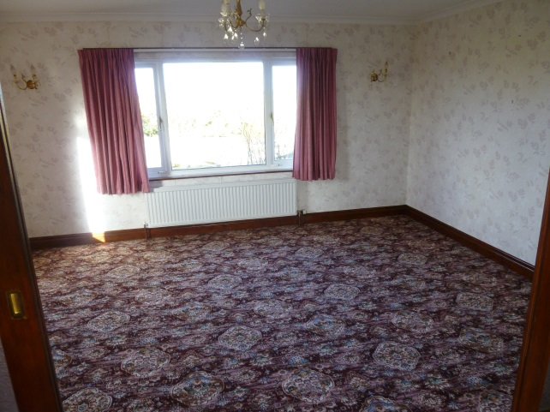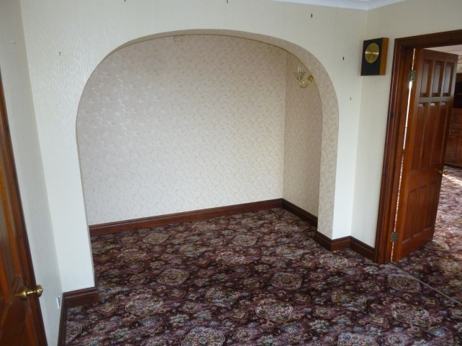

***Dining Room***

***Front Hallway***

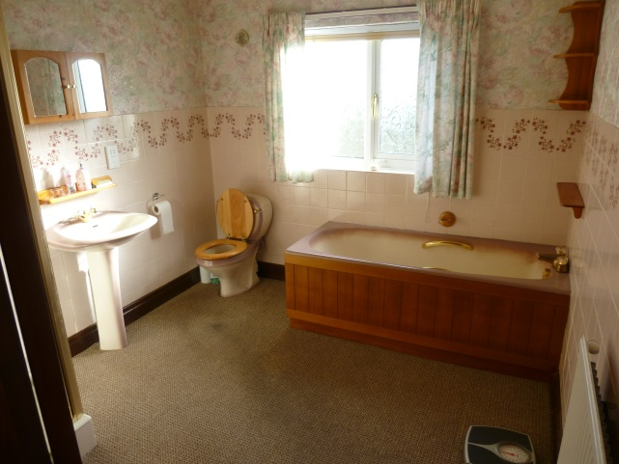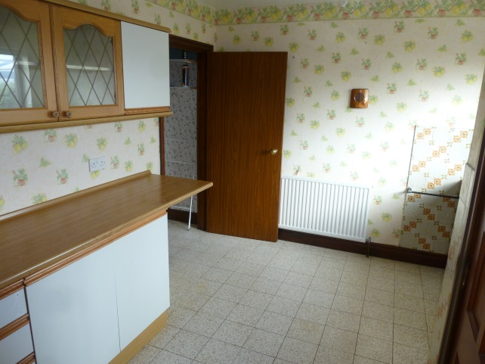

***Utility Room***

***Bathroom***

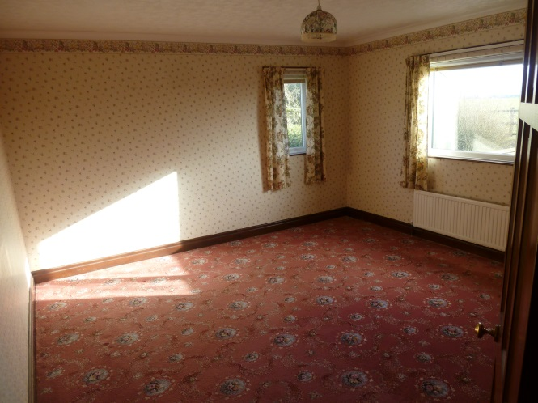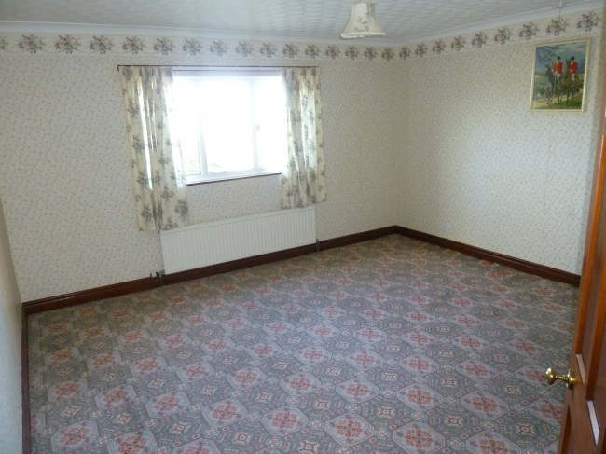

***Bedroom 3***

***Bedroom 2***

***Bedroom 3***

***Bedroom 2***

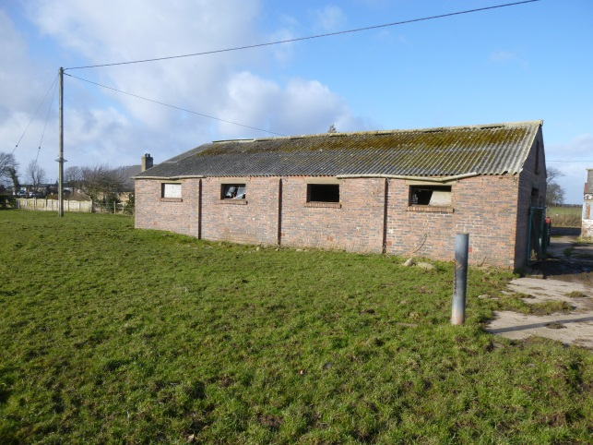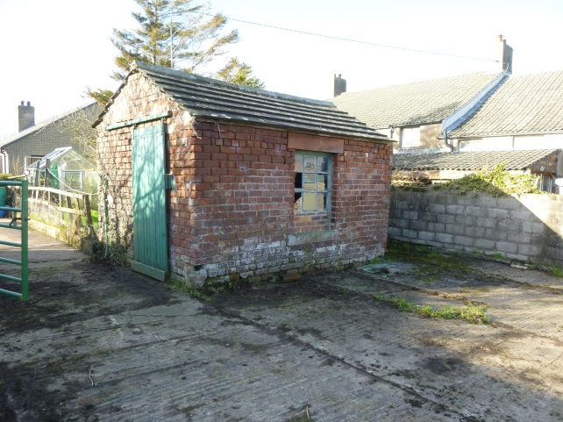

***Small Storage Shed***

***Brick Built Byre – Lot 3***

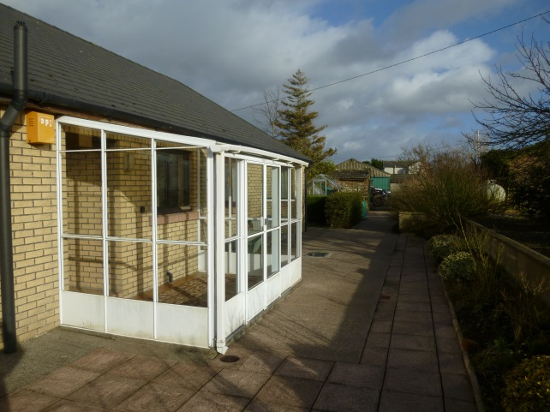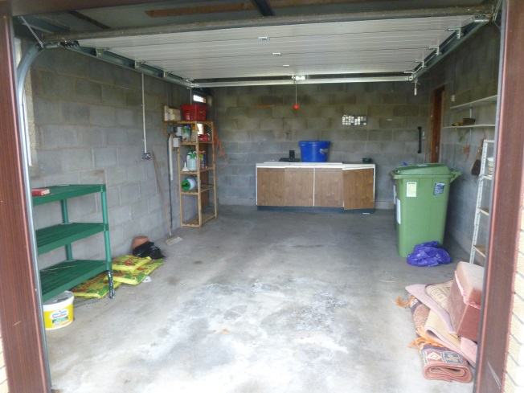

***Garage***

***Rear Elevation***

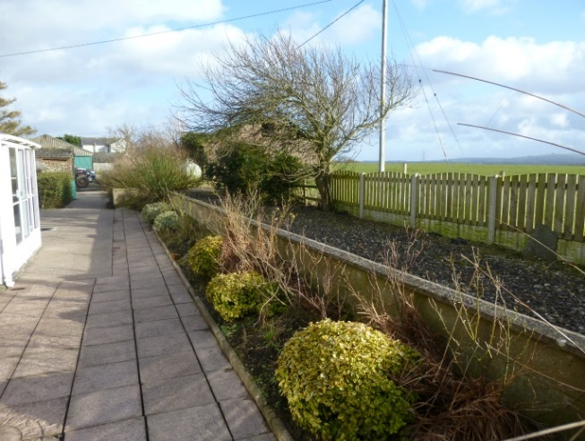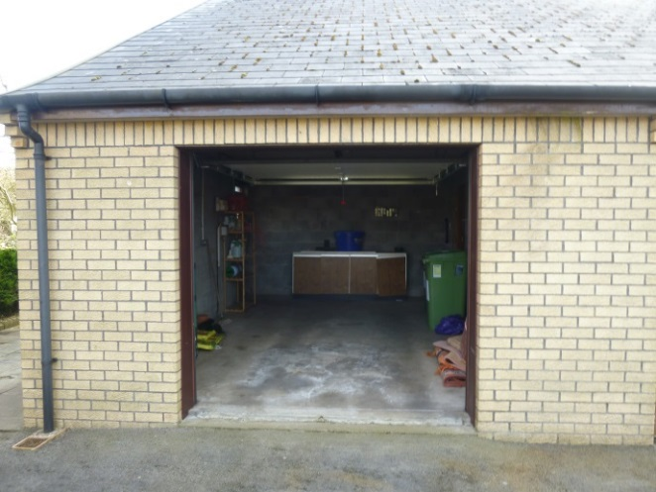

***Garage***

***Rear Elevation***

***Garage***

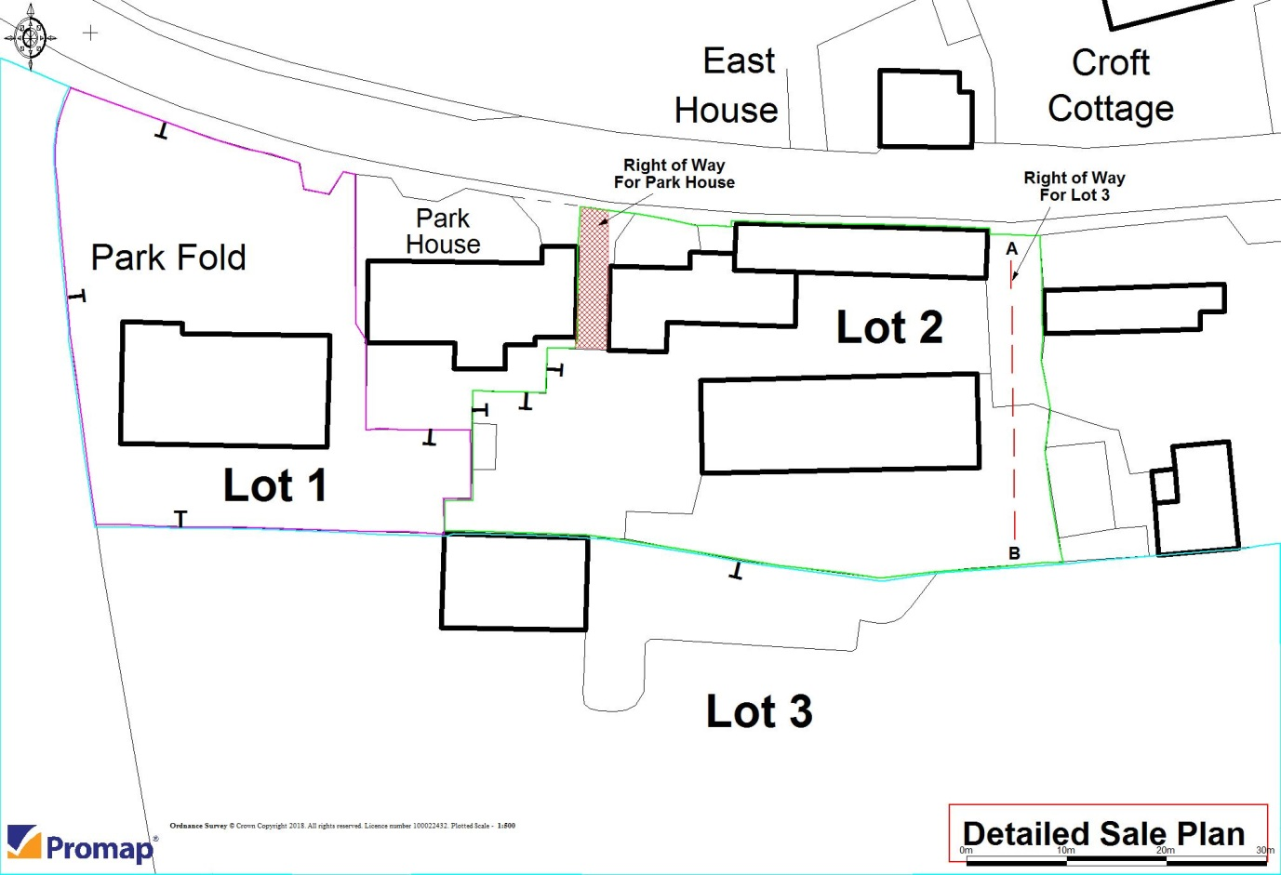

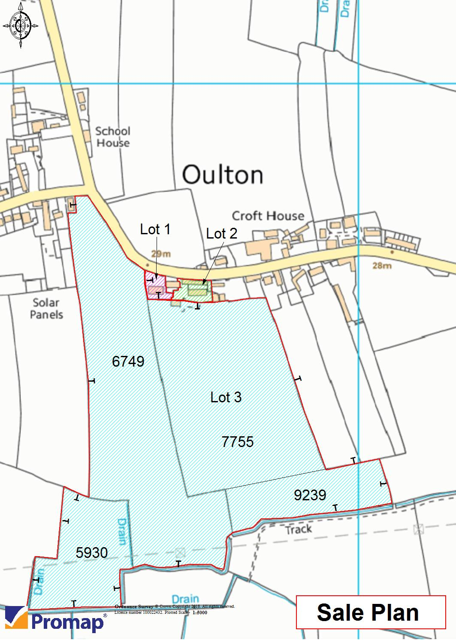

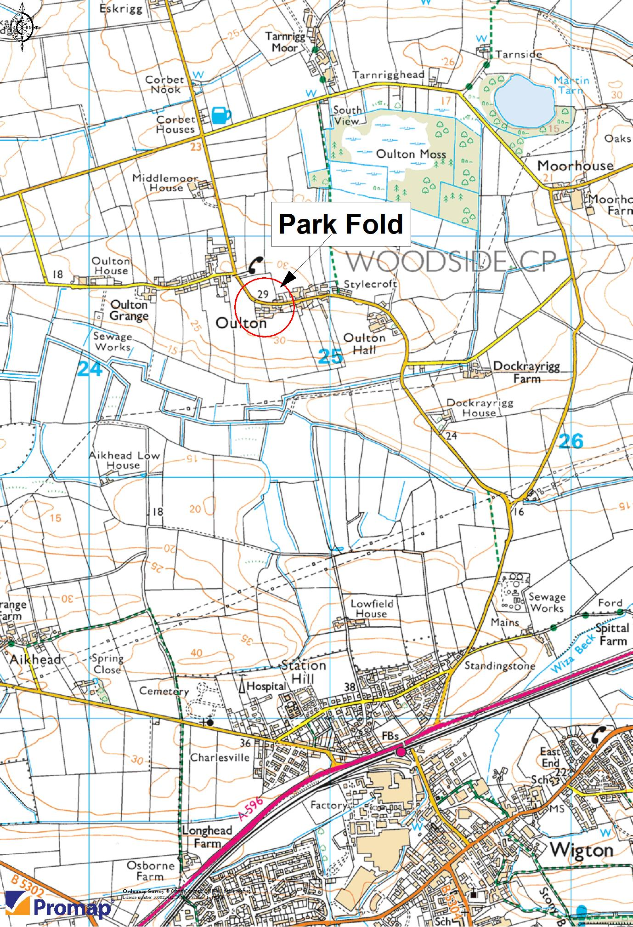

**NOTES**

……………………………………………………………………………………………………….

……………………………………………………………………………………………………….

………………………………………………………………………………………………………

……………………………………………………………………………………………………….

………………………………………………………………………………………………………

……………………………………………………………………………………………………….

………………………………………………………………………………………………………

……………………………………………………………………………………………………...

……………………………………………………………………………………………………….

………………………………………………………………………………………………………

………………………………………………………………………………………………………

……………………………………………………………………………………………………..

…………………………………………………………………………………………………….

…………………………………………………………………………………………………….

………………………………………………………………………………………………………

……………………………………………………………………………………………………….

Location Plan